Lab Session – Day 12

**Question:**

Use classicmodels. Show the highest MSRP for each productline using window functions.

Table: Products

The output should look as shown in below image.

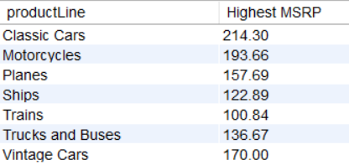

**Solution:**

Write the below query in MySQL workbench.

